## Pinterest :

* American image sharing and social media service designed to enable saving and discovery of information (specifically "ideas"[5]) on the World Wide Web using images and, on a smaller scale, animated GIFs and videos,[6] in the form of pinboards.[7]
* 400 million monthly active users as of August 2020
* 3+ billion items ( external - web link sharing )
* starting out as a "social network" with boards, later put increasing emphasis in visual search[23] and e-commerce,[24] such as shopping catalogs.[25]
* "catalogue of ideas" that inspires users to "go out and do that thing"

## User Onboarding :

* Collects Information :
  + Gender
  + Language
  + Country/Region
  + Tell us what you’re interested in
  + 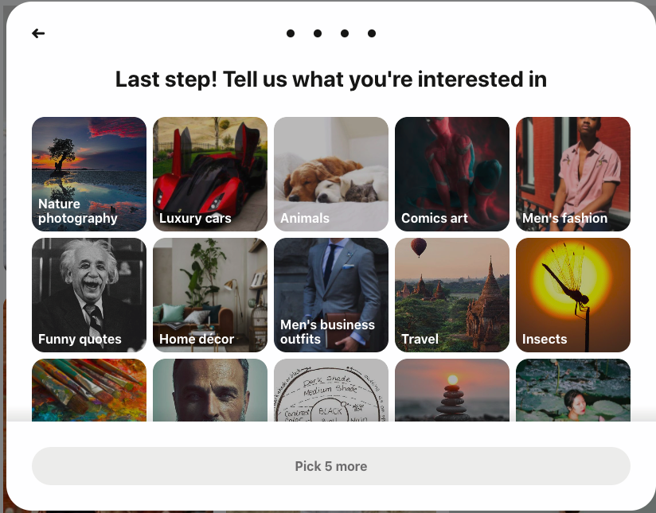

1. User skips the selection and continues to next section - Case 1
2. User selects a bunch of items according to his preference - Case 2

## How Recommendations are made :

Case 1 : User does not select any preferences :

System makes recommendation based on the following :

* Top N trending items in the ongoing week/month
* Editors’ Choice N items in the ongoing week/month

Case 2 : User selects preferences :

Collaborative Filtering : give suggestions to a user on the basis of the likes and dislikes of similar users. Without knowing anything about items and users themselves, we think two users are similar when they give the same item similar ratings.

1. Identify similar users
2. Identify their interests and recommend :
3. Evaluate predictions

### Identifying Similar Users :

Based on the information collected during onboarding, identify similar users using any of the following methods :

* cosine similarity
* Pearson similarity

Available data on the user will be converted to a **vector** form and similar user will be identified from existing user base.

### Identify their interests and recommend :

Data can be represented in a tabular form where each row contains data for a user and columns contain his interests/ratings given

Once similar user is identified, recommendations are made using existing user preferences which is going to be similar

### Evaluate Predictions :

Accuracy of the model can be measured by identifying :

* Whether the user clicked on the recommended image/story
* Whether the user pinned the recommendation to his board

Becomes a classifier problem where click/no click becomes (1/0).

Use metrics like accuracy, precision, recall, f1 score to evaluate the model.

## Content based filtering :

* requires a good amount of information of items’ own features, rather than using users’ interactions and feedbacks.
* For example, it can be movie attributes such as genre, year, director, actor etc., or textual content of articles that can extracted by applying Natural Language Processing

## Why content based filtering is difficult here :

* Cold start problem : no history available for the user
* Difficult to identify content from images/gifs/videos : will need to have image recognition/text detection models identify the content first and then feed to the recommender systems

## Limitations of Collaborative Filtering :

* Cold start problem ( item level ). When a new item coming in, until it has to be rated by substantial number of users, the model is not able to make any personalized recommendations.
* Bias towards frequent items : for items from the tail that didn’t get too much data, the model tends to give less weight on them.

## Ideal Recommender :

* Best of both approaches : add some dimensions of keywords that are explainable
* Give both predictions : let user decide based on his preference
* Evaluate and improve the models further